Youdle

CO600 Technical Report

Youdle: A new online system for gamified learning

Saahil Shah (ss2357), Tope Balogun (tb520), Miracle Okeke (mico2), Clifford Yeboah (ca517), Aziz Moore (aas49)

Table of Contents

1.Abstract 3

2.Introduction 3

3.Backgrounds 3

4.Scrum and Agile Development 4

5.Designs 4

6.Aims 5

6.1 User Stories 5

7.System Architecture 5

8.Problems 9

9.Testing 10

9.1 User testing- 10

10.Conclusion 11

11.Further improvements 11

12.Bibliography (References) 12

13.Appendix 14

**1.**  **Abstract**

“Youdle” aims to create a new online learning system aimed at students studying computing using interactive gamification with educational resources. We use API to generate computing-based questions and a user management system that stores data to provide access to resources and extended features. The project resulted in three quizzes of varying difficulty levels. Users can further input their data and view their progress on a leader board, this gives the user an opportunity to keep track with their progression. Additionally, a chat feature was implemented for educational discussions with a comments section in addition to a discussion forum for more interactivity.

**2.**  **Introduction**

For this project, our task was to produce an online system that is directed to students who are looking for an interactive game-like learning experience with a social aspect that offers even more resources to maximise the learning of the user, instead of just having a regular system that encourages learning. We wanted our users to have an easy experience navigating our site on their chosen browsers.

This report will go into detail on all aspects of the project, including ideas, background, technologies, and languages used, the system architecture, challenges, Testing and problems.

At the beginning of the project, we started by building off an existing idea that was presented by one of our group members and we were able to develop it through research, going through the process of creating different concepts. We created a draft website that consisted of pages like an about us page, and just a simple layout that would help us understand what it would be like to create a site that would be adaptable to our idea. In our weekly meetings, we would present the ideas and discuss further what we would like to do and the outcomes that we would like to achieve with our ideas. Our first concept was “**Moodle++”** which would have been an extension of Moodle, but we decided to do something that offers more than what Moodle offers. After we had our concept agreed upon and the layout finalised, we then just started working on putting the ideas we had into practice to deliver what we had set out to.

**3.**  **Backgrounds**

We looked at websites and applications that attempt to achieve similar goals as our project. Moreover, we thought that some of these websites appeared clunky and provided features that hampered the user experience. So, we made the choice to search the websites for features that weren't offered by these competitors but would be a wonderful addition to ours.

We were aware that every "new" user to our website would feel frustrated by their inability to navigate and opt to leave the site altogether since it is too difficult to use. To overcome this issue, we made sure that our website was easy to navigate, and the content was more scannable. We would use a navigation menu and a logo button that would take you back to the homepage.

Making our content prominently displayed makes it simpler for visitors to swiftly examine the text. The users would think our website is easier to use and are more likely to come back in the future.

We wanted to make a quiz website that was tailored to Computer Science students and to allow users to complete quizzes, see their rankings on the leader board, contact us via a contact form (if users have an enquiry), an article page, Video guides and interact with other users using the discussion forum or chatbot. The user would register their details which would be saved in the database. They would be able to login in and logout of the website.

**4.Scrum and Agile Development**

Scrum is a method adapted by many large technological companies to ensure a smooth and compact agile process. We created a product backlog where all the tasks needed to be implemented were stored in the form of user stories. We then went ahead and created ‘sprints’ which was a cycle that would occur every week. Here, we would take a group of user stories, and aim to complete the tasks within that sprint.

To track the completion of these tasks we created a sprint tracking form where for every sprint we would have every group member’s name with their assigned tasks, and at the end of the sprint we would write its status, whether it has been completed, in progress or not completed.

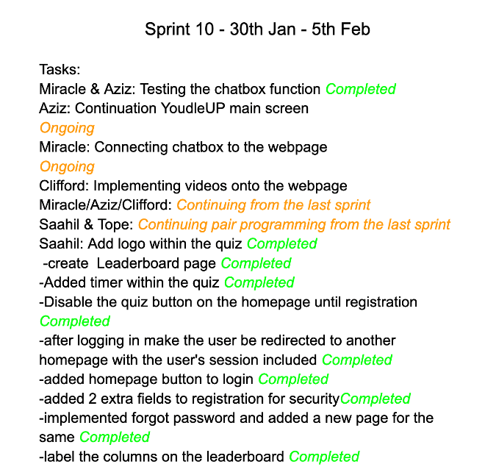

We thought this would be a suitable method as each team member would be working on their task while also being able to see the progress of other tasks. The scrum development process also requires us to have daily “stand up” meetings for every group member to give an update on what is completed and what is left. As a group, full of university students with other commitments outside the group work, daily meetings couldn’t occur every time, so instead we would update each other via our WhatsApp group conversations.

At the end of every sprint, we would have a meeting and discuss what has been completed and what has not been completed since the sprint started. The tasks that were not fully completed were moved to the next sprint and the ones that were completed we would update the project backlog and mark it as completed.

When assigning tasks for the next sprint we would follow several steps. Firstly, we would take a few user stories as tasks from our product backlog, then we would assign a number from 1-10 depending on the importance of the task and then assign each group member a task. This was helpful as we could know how much effort and attention should be given to each task.

We also recorded meeting minutes to show what was discussed in the meetings. The meeting included who attended and did not attend the meetings.

**5.  Designs**

**5.1 LO-FI Designs**

As part of our development process, we created several designs as of how we would want the pages and features to look like. Our first step was to create simple sketches known as LO-FI designs. All the members of the group created these designs so that the group could identify what features were more vital. After creating our LO-FI designs, we had a meeting where we reviewed all the designs and we got a brief idea on how the website would look like in terms of design, features, and the navigation.

*(****See appendix for an example of the lo-fi designs****)*

***(The rest of the lo-fi designs can be found in the corpus of materials)***

**5.2 HI-FI Designs**

After discussing this, we went ahead and created our HI-FI designs. In this step our designs would be strictly based on how the page layout and structure would look and did not include any colour or CSS properties.

*(****See appendix for an example of the hi-fi designs****)*

***(The rest of the hi-fi designs can be found in the corpus of materials)***

**6.**  **Aims**

Our primary aim for this project was to create an online learning system to include concepts of interactivity with gamification & resources for the computing community. In preparation for our project all our members created a list of user stories which would include the full feature list that we would like to implement in our website.

**6.1 User Stories**

User stories allowed us to initiate the implementation of our project. Some of them include:

* As a developer, I want the difficulty of the quiz to cater to everyone so that everyone has a fair chance.
* As a user, I want to be able to register and login in securely so that I can access the website.
* As a user, I want to be able to send a message to the Youdle team so that I can contact them.
* As a user, I want to be able to chat with other users so I can be able to discuss the quiz & other things.
* ​​As a user, I want there to be additional material and learning resources so that I can gain extra knowledge.

We put all the User stories together which created a product backlog, we used this to prioritise what to implement first in our project and then used it to track if any of the tasks were being completed. This helped us thoroughly get through our sprint cycles too. How the tasks were assigned through the group was via strength & pure interest. In some cases, there were some tasks that did overlap with other members, this introduced team task works such as pair programming.

We needed to consider that not every feature listed would be implemented due to it being unrealistic or even a change in direction. On the other hand, we could add more to the list due to finding better opportunities to do so. We then proceeded with the implementation of our website. Through this, we took into consideration prioritising how the user should experience our features.

**7.**  **System Architecture**

This section will give a comprehensive explanation on the features and technologies that we used in our project and a justification to why we used them. It will also explain how we integrated the concept of User Experience (UI). The functionalities and languages that were used in this project were not familiar to all group members as some of the group members have never used them while therefore this provided a better learning experience providing us with new skills and better developers.

The two technologies that we used in this project for the backend side were MySQL and PHP. These were the technologies of the XAMPP stack. Our tables are provided by MySQL which include details of all the users, the scores for the users who attempted the quizzes, and comments for the discussion forum.

**Login and Register system-** The register page will store all the details of the user such as name, email, password, security question, security answer and gender in its correct format in the database. We considered the fact of security as information such as the password needs to be stored securely since it is vulnerable to hackers. We managed to do this using a powerful hashing algorithm called **password.hash().** This algorithm encrypts the password before entering it into the database, which is the safest option compared to the MD5 algorithm where reverse lookup on the string can be used. The user must first register with their personal information. The email input field was integrated with a pattern that the user must follow for the email to be registered. Due to security the password must also provide a specific format which is mentioned to the user when typing the password. Once registration is completed, the user must login by entering their email and password. If the user has forgotten their password, they can reset it using the forgot password form by inputting their personal details including security question and answer.

**Homepage –** This is a standard HTML5 & CSS3 which includes the features you’d expect from a typical homepage, (navbar, supporting images etc) a hub which essentially links all the features available in our website. However, they’re buttons that are disabled to the user. This was done to introduce the exclusivity that we created for our users. The user would have to login first, where they will be redirected to the homepage in which the button functionality will be made available to the user to proceed further into the website. As the users' information is stored in our database it enables us to personalise the homepage to each user, this is done via a PHP session. The homepage includes buttons to the quiz board, Youdle up, FAQs, and other contact information.

**Quiz board –** This is also like the homepage; however, its purpose is different, it links all the quizzes together on one page. We also push a PHP session to the webpage which will welcome you as you proceed to play our quizzes.

**Quiz –** There are three quizzes in this section, which differ in difficulty, (easy, medium, hard) in terms of HTML and CSS they all consist of the same user interface with a game of background colour (to indicate what difficulty is what visually). Furthermore, the style of these quizzes are multiple choice questions which uses a question API that enables each question to be produced automatically through JavaScript using the **fetch ()** function. JavaScript also enabled the interactivity concept of the quizzes by allowing instant feedback on whether you have gotten the answer correct or incorrect, with colour indicators too. This is to give the users that instant gratification. Furthermore, this programming language allows the score of the user to reach the end of the quiz via a **localStorage.getItem ()** function, this is so the user gets reassured of their score at the end. We also provide a live score which increments each time you get a question right within the quiz. In addition, a timer is provided which decreases to zero which will automatically change to the next question. The user can view a leader board for all the quizzes to see their rankings amongst other users.

**Discussion forum**- In this section users can post comments and reply to an individual comment made by any user. This forum is provided with an input form with two input fields: name and comment. The main comments made are displayed in purple while the replies made are displayed in green. The forum uses the MySQL database and inserts the comments made by the user. There are two types of comments made by the user; a main comment which will be given a parent id of 0 and a value for the comment id, and a reply, whose parent id will be the comment id of its associated main reply. The code will display all the main comments on the page in the appropriate format (in a form of a purple comment panel) and the code will then loop through each of these main comments to see if they have an associated reply, if they do then the reply is displayed in its appropriate format (in form of a green comment panel right below the comment the reply was made to). The code includes an event handler which will send the data (comment) via AJAX to the comments page with the POST method and JSON format.

**Youdle up-** This is another feature which consists of a main screen with 3 buttons; i) Video guide which displays education videos tailored to computing students where the user can watch any of the videos, and post comments regarding the videos. ii) articles which includes a rss feed that displays articles about the latest technology news and is automatically refreshed daily. iii) chat bot which allows you to chat to a bot that generates responses based on the questions you ask.

**Contact form-** This form is used if the user needs to contact the Youdle team. Using the $_POST super global, the code retrieves the values entered by the user in the form fields and stores them in variables: $name, $email, $phone, $subject, and $message. Using the form data, it generates the email body message. It configures the email headers, such as the "From" and "Reply-To" addresses. It sends the email with the specified parameters using the mail() function.



**Chatbot-** There is also a chatbot provided where the user can ask certain type of question and get a response. This chatbot contains JavaScript code that bases its output on the user's input, which it accepts as a parameter. The function has several conditional statements that compare the input to predetermined strings and return a result when appropriate. For instance, the function will return "Guess my name" if the input is "What is your name?". The function includes help with quizzes, website navigation, and chatbot jokes, among other things. Responses to positive and negative comments made on the website are also included.

**User interface design –** Considering our audience, we made sure the interface design had similar features to the existing interfaces that users frequently use, which allows them to easily navigate through our website and to naturally expect things within the websites. The assistance of the Seven Principles of UX design, enables us to align the purpose of our website for the Users. **‘Consistency'** is essentially when users will come to your site with a pre-existing idea of how things “should work”. With the use of this principle, it allowed us to take consideration of the user’s perspective when they’re navigating throughout our website allowing us to make sure we prioritise the layout of the website to make sure the navigation is easy for them. A great example of this would be our homepage. Our Logo is on the top left of the page. This is justified via research, an eye-tracking study by Eyequent says that the upper-left corner gets the most attention when a user visits a website. We also made sure to enable a link on our logo as this is expected on most websites.  Another principle we used in our website would be *`***hierarchy`**. A site hierarchy is the arrangement of pages on a website, the benefits of this will allow the website to flow naturally for the user. How we achieved this was mainly using the **href=”” function**. This enables us to link web pages together, placing them within buttons, pictures or even words. Creating that fluid illusion where the user won’t feel stuck.

We chose the colour Blue as the main accent of colour throughout our website, as with the prior studies of human computer interaction & common colour associations we understand that the colour blue is a common colour that is recognized by users as its primary colour, in addition, we are aware of the associations that blue comes with such as: Calm, competence, logic & reliability. Which all have relevance to what our website provides.

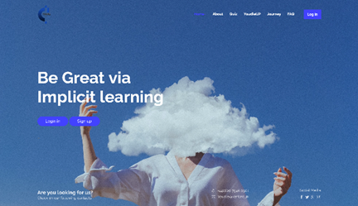

“Making things visible” is another principle we included in our website. We made sure everything in our website was easy to read and understand, making instructions quite self-explanatory. This was done by the choice of fonts and colours throughout the website. We also made sure that the logo appears in all pages and the size is consistent. We made sure that the colours stayed consistent for example, the login, register and forgot password forms, had the same font, colour, and design decisions. We chose two simple colours for this which were blue for the buttons and coral for the headings.

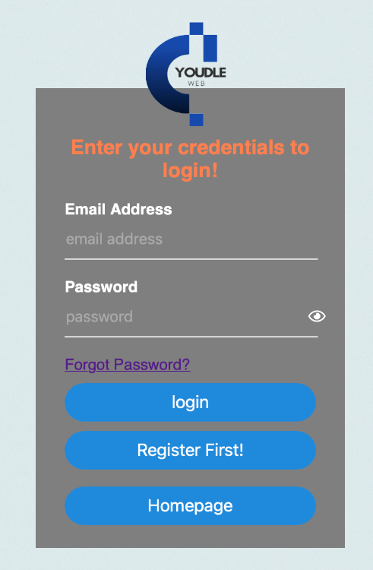

When the user types the password, the form will display a dialogue box called password requirements which change colour when the user types in their password. Initially all the text is in red and there is a small sad face to the left of every requirement showing none of the requirements have been satisfied, but as the user starts satisfying the requirements that text will turn into green and the sad face will turn into a smiley face. This in turn created a better user experience demonstrating Schneiderman’s Eight Golden Rule and Norman’s principle. The screenshot below shows the password requirement box without typing the password.

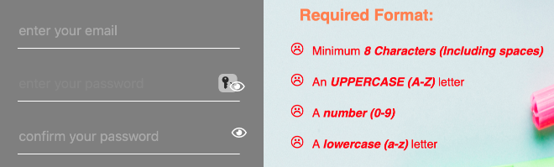

As you can see none of the requirements have been satisfied, but after typing the password in the correct format the dialogue box will appear as shown below.

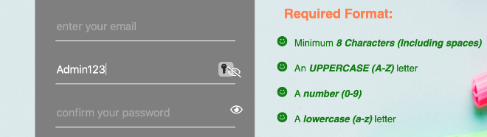

Schneiderman’s Eight Golden Rules were also considered when designing this website. “Error handling” and “providing informative feedback” was well demonstrated in our project. An example of this is via the error and success messages. i) **Registration form- “User already exists” error** message when the same user tries to register twice, ii) **Login form**- when a user enters an incorrect email and password, an error message saying incorrect details is displayed. Other errors such as “this field is required” and password not matched is also included. The error messages are well informative and give the user clear details on what is going on as shown in the pictures below.

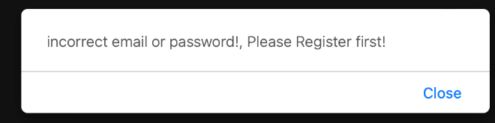

Another feature that we implemented was the discussion forum. The button for this is in the quiz board next to the quizzes. We decided to put the button there as users could have a discussion before and after playing the quiz and this would be a good way to interact with their fellow peers. The picture below shows the location of the button and as illustrated the button is eye-catching and stands out to give a better user experience.

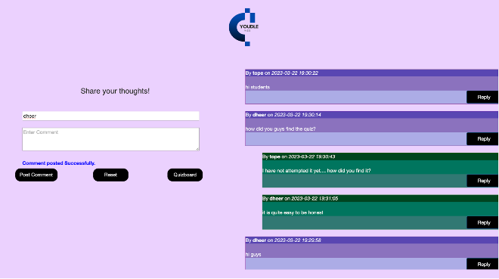

We decided to use purple and green as the choice of colours, purple for an individual comment, and green for a reply comment. This makes the page to be clearer to the user enhancing better user experience and making it more clear and more visible. We put the form and the conversations beside each other because it makes things more visible and refuses complexity. Making the replies green was inspired by WhatsApp.

**8.**  **Problems**

There were a few problems that our group had encountered during our development process. Initially in our early stages of development, setting up the MySQL database was an issue as xampp was having errors whilst running which delayed our development process at the beginning.

Every time a new feature was implemented or changed it would disrupt some of the sessions made. This was something that we were expecting so at the start we decided to test the features as soon as they were implemented and to do a simple run through the whole website every one or two weeks so that if there are any errors they can be addressed and can rectified instead of finding out about the errors later when we are in the final stages of development.

One of the main challenges we faced was, when a user finishes the quiz, we wanted the score and the user's name to be automatically added to the database table for the high scores to be displayed by simply clicking the save button. We couldn't find a way to extract the score from the local storage since that is where the score was saved. We came up with an alternative solution where, after the user completes the quiz, he/she would be prompted to manually enter their name and score and on-click of the save button, the 2 values would be inserted into the database table via an insert statement. We then made this our alternative solution. However, in the final stages of development (few days before the deadline) we conducted a final user test in which we observed that this alternative solution that we produced was very unprofessional and we noticed that users would often cheat and input a high score just to be at the top of the leader board. This meant we had to change this concept, so after doing a lot of research we finally managed to get the score and the user’s name to be automatically added to the database/ leader board. This was done by getting the name to be displayed on the name input field via php sessions, the score to be displayed in the score’s input field by setting the value attribute to the variable “mostRecentScore” which was where the score was saved. Then we made those input fields hidden so now when the user clicks on the save button the score is automatically saved to the database to be displayed in the leader board.

In addition to that, we had a problem with how the quiz questions was displayed. We tried different versions of the API to see any difference, but they wouldn’t display. In conclusion to this, we decided to leave it as it is, the reason is because the quiz is still readable for the user.

We decided that the user would not be able to use any of the features without being logged in. Therefore we encountered a problem on where the user should be directed after logging in since different users have different preferences on what feature they would like to use first, so we came up with a solution that on the homepage we would disable all the buttons, but after registering and logging in, the user will be directed back to the homepage, but now with all the buttons and features enables so they can choose where they would like to navigate first.

We built a **Contact us Form** that allows users to send emails to Youdle Gmail. The contact us form was going to send messages from the localhost 'Xampp’ to our Youdle Gmail account... In the process of making this contact form we tried to use Phpmailer, but it failed to work. After doing some research, we configured php.ini and sendmail.ini files in the Xampp folder to include the Youdle Gmail account, SMTP Gmail and SMTP port and it was working fine.

Originally, we had a task to implement a chat box where users could have one on one conversations with each other. Due to the time factor the group member who was assigned to do this task was not able to fully implement it and had missing features in it, therefore as a group we decided to disregard this idea and implement a chat bot instead. With the chatbot, the issue we encountered. was due to the installation of libraries in Python, which prevented us from running tests to examine the code. we couldn't come up with a solution to this problem so to address this issue, we created a simple chatbot that provided you with responses related to the website.

**9.**  **Testing**

During our full stages of development, we conducted tests frequently. We made sure that we would test any new feature or any changes in code implemented so that we can know what part of the code needed fixing instead of reaching a later stage of development and having large and bulky lines of code to test. For every feature that was implemented by a member, it would be run and tested by another group member on their own browser due to cross- browser compatibility. The member who tested the feature would produce a document indicating what functionality works and what doesn't. This document will then be sent back to the member who implemented the feature where he/she would correct the errors and then update the document.

**9.1 User testing-**

In our later stage of development, once most of our implementation was complete, we decided to test the full website on different users. Since the audience of this website was mostly students and the content was mostly directed towards computing students, we decided to hand the website to a group of 6 computing students from our course.

We then told each of the students to navigate through the website and highlight to us any problems they encountered and any further improvements that they thought would be essential for our website. This helped us to point out quite a few bugs and any improvements to enhance user experience. Additionally, we got a great amount of feedback from different students and lecturers during the poster fair held at the university which we took into consideration as well.

After fixing all the bugs and making the necessary improvements, we carried out another final user test few days before the final submission, but we now asked a different group of students to test the website for us. From the feedback we received and feedback from our supervisor, we noticed that the users were more happy and more comfortable with the changes we had made. However, there were 2 things we observed.

Firstly, the feature where once a user completes the quiz, they would have to manually input their name and score for it to be saved to the leader board, was creating issues in terms of professionalism and this was prompting users to cheat their score. So, we had to change it back to our original idea which we initially were not able to implement. Thankfully we managed to solve the issue and remove the concept of users having to input the score and the name and instead be automatically saved by just simply clicking the save button.

Secondly, we observed that majority of the users don’t prefer the leader board table to be a scrollable window but instead prefer it to overlap and the page to be scrollable instead of the table. We made this change to all the leader boards for all quizzes.

Since these two changes made were last minute, they were not included in the earlier test documents we had created when testing the quiz, therefore we created another separate final test document for these two changes, this is included in our testing folder.

**10. Conclusion**

Overall, as a group we succeeded in our task of creating a new online learning system aimed at students studying computing using interactive gamification with educational resources as we have met most of the goals that were set out in our project plan. Users are successfully able to register, login, change their password, play the quizzes, have a discussion with other users, chat with a chatbot and find additional resources of materials for the course. Throughout our course of development, we did come across many difficulties, but we kept the motivation ongoing and never gave up. Unfortunately, we lost one of our group members in the middle of our development process which increased the workload and implementations for the rest of the group members. This did have an impact on the rest of the group members, but we made it our primary goal to focus and make this project our priority so that we can reach the final goal.

We successfully and thoroughly tested our system as well as every component of the website. The testing, particularly the user testing, was beneficial in making our website easy to use for a novice and user-friendly.

We used raptor as our workspace and for storing our files, we found this easier as it was simplistic and any update or changes, we made to the workspace was updated in our sprint tracking form and via our group conversations on WhatsApp or Microsoft Teams.

As a result of this project compared to other similar quiz applications such as trivia, we have personalised our website to have additional features such as a login and register system, a discussion forum, a chat bot, and provided additional resources to improve the learning experience.

There were some decisions and ideas that were made to ensure a better user experience such as, not providing a marking scheme for the quiz, which would bring the concept of competition, and this will force the students/users to go out of their way to do more research and learn more about the topic.

This project showed us that the major goals of completing a good project are cooperation, timeliness, and communication. Aside from sprint meetings on teams, we communicated via WhatsApp. Whenever a task is completed or unclear, one of the group members will simply send a message to the WhatsApp group, and we will all check into it. Because every group member had access to WhatsApp, this was a very simple and effective method of communication.

**11.Further improvements**

As much as a website/project can be good, it cannot be perfect. Even though we managed to reach our final goal, there are few improvements that we would have made given more time and in the future.

One of the improvements we would have made was to implement an additional feature/ interface that lets the user create an additional and customised quiz. This would let the user choose the type of questions, number of questions and make the quiz the way they want. Due to the time factor, we were unable to implement this.

Another improvement was to have the “remember me” functionality on the login where the user would not need to enter their credentials every time, they visit the website.

We also thought that having a progress feature where a graph would be presented to the user showing their progress with the quizzes they have taken and suggest hints and tips for the future would be a good feature to add to the website.

We felt that there was a great scope of improvement for the chatbot where we would train it to ensure that the bot is equipped with the necessary knowledge to start out by giving precise replies to specific inputs. Since our initial idea of this concept was to create a chat box that allow user to have one on one conversations with each other, would prioritize this idea and implement it fully.

Finally, even though our user testing was successful and enough, given a similar project in the future, we would broaden our testing to have students from other universities and employers who work in web development to test our system as well.

**12.Acknowledgements**

Finally, we would like to sincerely thank our project supervisor Professor Shujun Li for advising us and motivating us throughout the project.

**13. Bibliography (References)**

* www.youtube.com. (n.d.). *Make a chat in Unity in 6 minutes! - Fishnet Tutorial*. [online] Available at: https://youtu.be/g-tGM_n2kR4 [Accessed 29 Mar. 2023].
* www.youtube.com. (n.d.). *create a Quiz Website using PHP and MySQL [ Online Quiz System in PHP Project with Source Code ]*. [online] Available at: https://youtu.be/veVZRLwfe6o [Accessed 29 Mar. 2023].
* www.youtube.com. (n.d.). *ONLINE QUIZ SYSTEM IN PHP and MySQL | Source Code & Projects*. [online] Available at: https://youtu.be/PxMjn9ii6ao [Accessed 29 Mar. 2023].
* www.youtube.com. (n.d.). *Introduction to Python - Lesson 6 - Making a Quiz Game*. [online] Available at: https://www.youtube.com/watch?v=cwJBEZjQJtc&ab_channel=MrDimmick%27sComputingChannel [Accessed 29 Mar. 2023].
* Python, R. (n.d.). Build a Quiz Application With Python – Real Python. [online] realpython.com. Available at: https://realpython.com/python-quiz-application/ [Accessed 29 Jun. 2022].
* www.youtube.com. (n.d.). *Build A Quiz App With JavaScript*. [online] Available at: https://www.youtube.com/watch?v=riDzcEQbX6k&ab_channel=WebDevSimplified [Accessed 20 Mar. 2022].
* www.youtube.com. (n.d.). *Building a Multiple Choice Quiz | Java | Tutorial 29*. [online] Available at: https://www.youtube.com/watch?v=nCIjHTlztNg&ab_channel=MikeDane [Accessed 29 Mar. 2023].
* www.youtube.com. (n.d.). *Build and Deploy a Full Stack Realtime Chat Messaging App with Authentication & SMS Notifications*. [online] Available at: https://www.youtube.com/watch?v=MJzbJQLGehs&ab_channel=JavaScriptMastery [Accessed 29 Mar. 2023].
* Shannon (2015). *How to Create An Engaging Website Design - AddThis*. [online] AddThis Academy. Available at: https://www.addthis.com/academy/how-to-create-engaging-website-design/.
* www.addthis.com. (n.d.). *Why the Right Colour Palette Matters for Your Brand - AddThis*. [online] Available at: https://www.addthis.com/blog/2015/08/18/why-the-right-color-palette-matters-for-your-brand/#more-12006 [Accessed 29 Mar. 2023].
* Pexels (no date) *100,000+ Best Website Background Images · 100% Free Download · Pexels Stock Photos*. Available at: https://www.pexels.com/search/website%20background/.
* Davies, N. (2020). *The 7 principles of UX design—and how to use them*. [online] 99designs. Available at: https://99designs.com/blog/web-digital/ux-design-principles/.
* Corrigan, S. (n.d.). *How to Strategically Use Colour in Website Design*. [online] www.flux-academy.com. Available at: https://www.flux-academy.com/blog/how-to-strategically-use-color-in-website-design.
* EyeQuant – Data Driven Design. (n.d.). *EyeQuant – Data Driven Design*. [online] Available at: https://www.eyequant.com/.
* www.youtube.com. (n.d.). *Build a Quiz App - Intro*. [online] Available at: https://www.youtube.com/watch?v=u98ROZjBWy8&list=PLDlWc9AfQBfZIkdVaOQXi1tizJeNJipEx&ab_channel=JamesQQuick [Accessed 29 Mar. 2023].

**14. Appendix**

Lo-fi design

Figure 1.1 shows the initial draft (LO-FI) of the quiz.

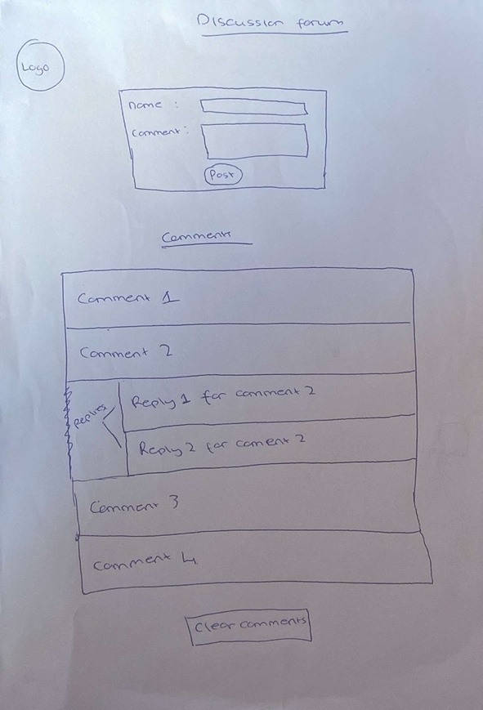

Figure 1.2 shows the initial draft (LO-FI) of the Discussion Forum

Hi-fi design

Figure 1.3 shows the final design (HI-FI) of the quiz.

Figure 1.4 shows the final design (HI-FI) of the Discussion forum.